

SECUREVAULT: PASSWORD-BASED DIGITAL SECURITY VAULT USING MIPS ASSEMBLY LANGUAGE

Computer Architecture Project Report

Submitted To: Ma’am Tayyaba Shahzad
Submitted By: Abdul Hannan (47524), Mohtasim Iftikhar (41262)
Course: Computer Architecture
Semester: Spring 2026

Abstract
Digital security is an essential requirement of modern computing systems. Almost every computing device uses authentication mechanisms to protect sensitive information from unauthorized access. This project presents SecureVault, a password-based digital security vault implemented using MIPS Assembly Language and simulated using the MARS 4.5 environment.
The system demonstrates low-level implementation of authentication, controlled access, memory management, file storage, data retrieval, deletion, and update operations. Through this project, fundamental Computer Architecture concepts such as processor registers, memory organization, branching, looping, procedures, stack operations, and system calls are explored in a practical manner.
The SecureVault system successfully provides a secure environment where users must authenticate themselves before accessing protected file operations.

1. Introduction
Modern computer systems depend heavily on security mechanisms to protect confidential information. While high-level programming languages provide convenient methods for implementing security systems, they often hide the underlying hardware operations.
This project focuses on implementing a security vault directly in Assembly Language to better understand how processors execute instructions and manage memory resources.
The project allows users to:
- Authenticate using a password
- Create virtual files
- Read stored files
- Delete files
- Update file contents
- View all stored files
- Restrict unauthorized access
The project demonstrates how security features can be implemented at a low level using processor instructions and memory management techniques.

2. Problem Statement
Most modern applications implement security through multiple software layers, making it difficult to understand how security functions at the hardware level.
The objective of this project is to design and implement a secure digital vault that demonstrates:
- User authentication
- Access control
- Memory-based file management
- Secure storage and retrieval
- Monitoring of failed login attempts
- System lock functionality
using Assembly Language concepts.

3. Objectives
The main objectives of the project are:
- Implement password-based authentication.
- Demonstrate processor-level instruction execution.
- Apply memory allocation and management concepts.
- Implement secure file operations.
- Understand branching and control flow.
- Demonstrate low-level security implementation.
- Explore system calls and interrupt-driven I/O.

4. System Features

Authentication System
- Password verification
- Three-attempt limit
- Automatic system lock

File Management System

Create File
Stores file name and content in memory.

Read File
Retrieves content using file name.

Delete File
Removes file from memory.

Overwrite File
Updates existing file content.

List Files
Displays all active files.

5. Computer Architecture Concepts Used

Registers
The processor registers are extensively used:
- $t0-$t9 : Temporary storage
- $a0-$a3 : Function arguments
- $v0 : System call operations
- $ra : Return address

Memory Organization
The Data Segment stores:
- Password
- Login attempts
- File names
- File contents
- Status flags
The Text Segment stores executable instructions.

Branching Instructions
The system uses:
- beq
- bne
- j
- jal
- jr
for decision making and control flow.

Procedures
Modular procedures are implemented:
- copy
- clean_input
- clean_fname
- clean_content
- compare_read
- compare_delete
- overwrite_check

System Calls
Input and output operations are performed through MIPS system calls:
- Print String (4)
- Read Integer (5)
- Read String (8)
- Exit Program (10)

6. System Design

Login Phase
- User enters password.
- Password is compared character-by-character.
- If correct:
  - Access granted.
- If incorrect:
  - Attempt counter increases.
- After three failed attempts:
  - System locks permanently.

Vault Operations
After successful login:
- Create File
- Read File
- Delete File
- List Files
- Overwrite File
- Exit

7. Memory Structure
The virtual file system consists of five storage slots.
Each slot contains:
File Name → 20 Bytes
File Data → 100 Bytes
Status Flag → 4 Bytes
Total per file:
124 Bytes
Total storage:
5 × 124 = 620 Bytes
This simulates a simplified file allocation mechanism.

8. Algorithm

Authentication Algorithm
Start
Input Password
Compare Password
If Correct
Grant Access
Else
Increment Attempt Counter
If Attempts = 3
Lock System
Else
Retry Login
End

File Search Algorithm
Input File Name
Search File 1
Search File 2
Search File 3
Search File 4
Search File 5
If Match Found
Perform Operation
Else
Display File Not Found

9. Results
The SecureVault system successfully performs:
✓ Authentication
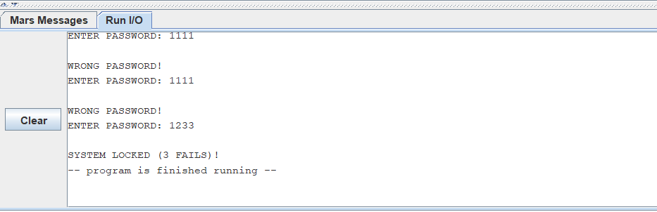
✓ Access Control
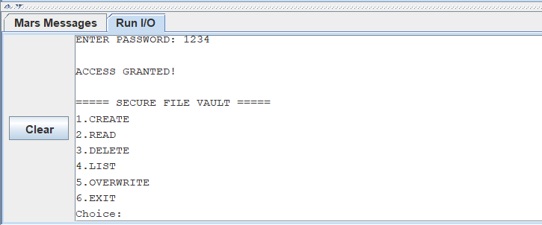
✓ File Creation
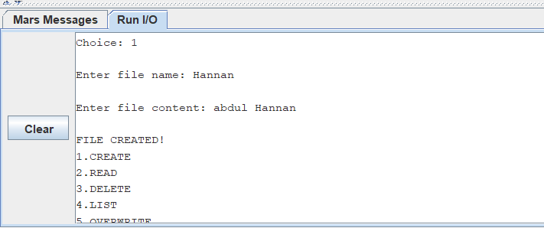

✓ File Reading
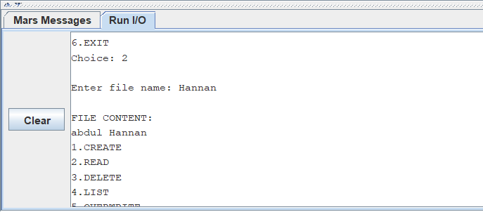
✓ File Updating
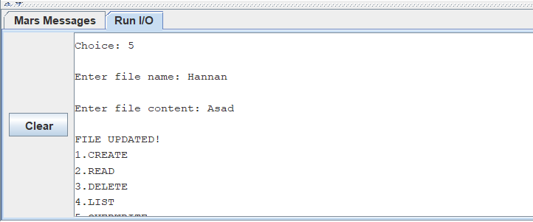
✓ File Listing
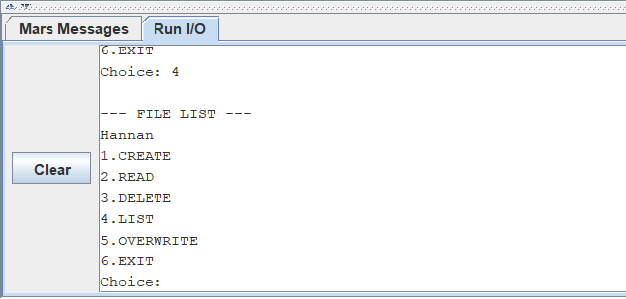
✓ File Deletion
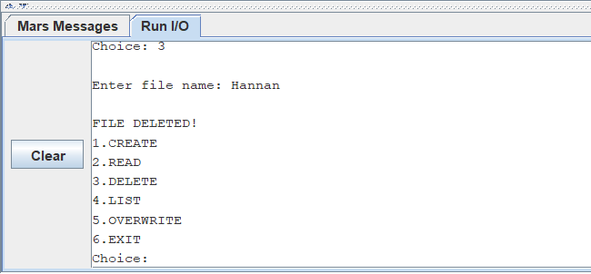
All operations were tested successfully in the MARS 4.5 simulator.

10. Hardware-Level Working
Although executed inside MARS, the system closely simulates real processor behavior.
When the user enters a password:
- Keyboard input is stored in RAM.
- Processor loads each character into registers.
- CPU executes compare instructions.
- Branch instructions determine success or failure.
- Memory locations store file information.
- Arithmetic Logic Unit (ALU) performs comparisons and calculations.
- Control Unit fetches, decodes, and executes every instruction.
Thus, the project demonstrates the complete Fetch–Decode–Execute cycle of a processor.
In real hardware:
Keyboard → RAM → CPU Registers → ALU → Control Unit → Output Device
The same process occurs physically inside the processor.

11. Advantages
- Simple and efficient
- Demonstrates low-level security
- Practical use of Computer Architecture concepts
- Easy to understand and modify
- Strong educational value

12. Limitations
- Fixed password
- Limited file storage
- Data lost after program termination
- No encryption

13. Future Enhancements
- Encrypted file storage
- Dynamic memory allocation
- Persistent disk storage
- Multiple user accounts
- File permissions
- Audit logs
- Advanced authentication mechanisms

14. Conclusion
The SecureVault project successfully demonstrates a password-protected security system implemented entirely in MIPS Assembly Language. The project integrates authentication, memory management, branching, procedures, and file operations while providing a practical understanding of processor-level execution.
The implementation bridges the gap between theoretical Computer Architecture concepts and practical system development. Through this project, valuable insights were gained into instruction execution, memory organization, register usage, and low-level security mechanisms.

References
- Patterson, D.A. and Hennessy, J.L., Computer Organization and Design: The Hardware/Software Interface.
- Stallings, W., Computer Organization and Architecture.
- Wang, S.P. and Ledley, R.S., Computer Architecture and Security.
- MARS MIPS Simulator Documentation.
- Rajaraman, V., Fundamentals of Computers.

